COMP3066 – Week 02 Assignment

- DUE: Week 03, beginning of the class.
- This is an individual assignment.
- The completed work has to be demonstrated to the instructor no later than the beginning of the Week 03 class. NOTE: the work that has not been demonstrated will not be accepted.

Objective: To Update SUSE Leap 15 32 bit Linux.

Task 01

- Package repositories: https://en.opensuse.org/SDB:Add_package_repositories
- Verify that the following repositories are added to the list:
  - Oss
  - Update
  - Non-oss
  - Update non-oss
  - Source
  - Debug
  - Update debug
  - Update debug Non-oss
  - The list of repositories: http://en.opensuse.org/Package_repositories

Here is how the output of the “zypper lr” command should look like:
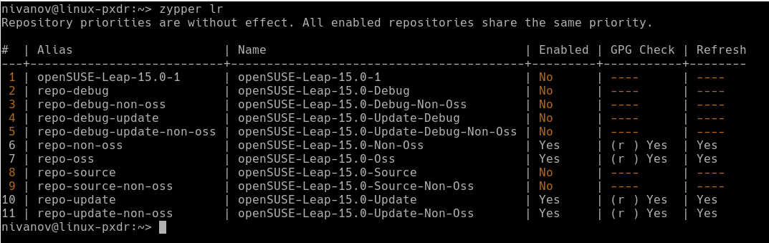
Task 02

- Perform system update
- Guide to performing system update: https://en.opensuse.org/System_Updates

Task 03

- Learn to use zypper as well as YaST software management to manage system/user software
  - Guide to using YaST software management: https://en.opensuse.org/YaST_Software_Management
  - Guide to using zypper: https://en.opensuse.org/SDB:Zypper_usage_11.3
- Install the following software:
  - nano (with YaST software management)
  - tree (with zypper)

